**<Customer Name>**

**<Project Name>**

**Business Requirements Document**

**<Version No.>**

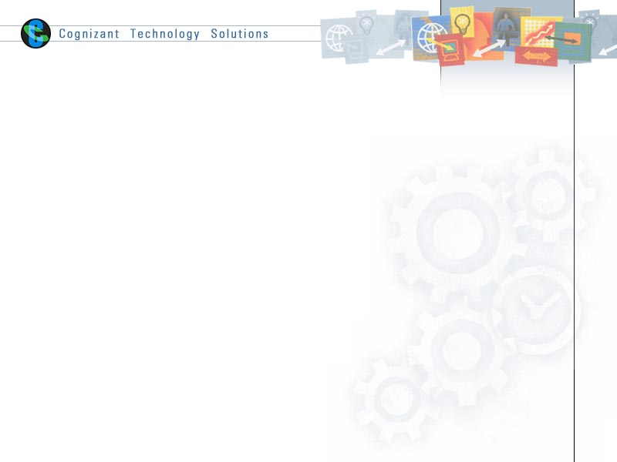

|  |  |  |  |
| --- | --- | --- | --- |
|  | Prepared By / Last Updated By | Reviewed by | Approved By |
| Name |  |  |  |
| Role |  |  |  |
| Signature |  |  |  |
| Date |  |  |  |

Table of Contents

1.0 Introduction 3

1.1 Purpose of this document 3

1.2 Project Overview 3

1.3 Scope 3

1.3.1 In scope 3

1.3.2 Out Scope 3

1.4 Intended Audience 3

1.5 Constraints, Assumptions and Dependencies 3

1.6 Definition & Acronyms 4

2.0 Organization Architecture 4

2.1 <Customer Name> 4

2.2 <End-Customer Name> 4

3.0 Process Architecture 4

4.0 Business Process Analysis 5

4.1 Current Scenario 5

4.1.1 ‘As-is’ Process Flow 5

4.1.2 Process Flow Details 5

4.2 Proposed Solution 5

4.2.1 ‘To-be’ Processes 6

4.2.2 Process Flow Details 6

5.0 Process Definitions 6

5.1 Business Rules 6

6.0 High Level Business Requirements 7

7.0 Detailed Business Requirements 7

8.0 Business Process to Requirements Traceability 7

9.0 Objective and Expectation Traceability 7

9.1 Business Objective Traceability Matrix 7

10.0 References 8

11.0 Change Log 9

# Introduction

## Purpose of this document

This document is aimed at

* Providing the necessary inputs to the detailed requirements gathering phase and further on for the SDLC processes.
* This document also serves to establish the traceability between the Business Objectives and the requirements identified in the proposed solution and how they satisfy the stated objectives.
* Provide expectation traceability in terms of the requirements and the user expectation
* Serves as a formal template for documenting the Business Requirements which also includes statutory and regulatory requirements.

## Project Overview

<Mention the overall functionality of the system and describe the objectives/ goals that would be accomplished when the system is implemented>

## Scope

### In scope

<This section should outline the business processes/ business areas that are scoped for the system being developed. For example, specific application processes, reporting modules, location specific business processes etc>

### Out Scope

<This section should outline the business processes/ business areas that are not scoped for the system being developed>

## Intended Audience

* All associates going for the initial study at new accounts/projects.
* Associates preparing the white papers/proposals for these accounts/projects.
* Delivery Assurance Group, Process Engineering group

## Constraints, Assumptions and Dependencies

<This sub-section should state all the assumptions, dependencies & constraints that affect the plan. It should identify the high-risk assumptions and, if possible, specify contingency plans for the same. The requirement constraints represent requirement decisions that have been mandated and must be adhered to.

Assumptions: Statements that are believed to be true and on which the business requirements depend. If the assumptions are not true, the business requirements might need to be changed.

Dependencies: Statements about external/internal environments, events, or business processes on which the business requirements are dependant.

Constraints: Facts that impose limitations or restrictions on the project. Constraints can be business, technical, regulatory, procedural, or historical. Some examples include: Business constraints (budgetary limitations, expenditure freeze, etc).>

## Definition & Acronyms

# Organization Architecture

<In this section, please list stakeholders of the project. These could include but are not limited to the users of the system, employees, clients, and partners of the company. Fill in the following table with the position, position description, and primary responsibilities (in bullet form) relative to the system. Create a new table for each organization (i.e., the “client”, their clients, their partners, etc)> ‘

## <Customer Name>

<This table provides a view of the client organization as it applies to this application development project. >

|  |  |  |  |
| --- | --- | --- | --- |
| Name & Position | Primary Responsibilities  (relative to project) | Module | Primary Responsibilities  (relative to application business process) |
|  |  |  |  |
|  |  |  |  |
|  |  |  |  |

## 

## <End-Customer Name>

<This table provides a view of the end-customer organization as it applies to this application development project. Please fill in this table only if the client has resources from his end-customer on the project >

|  |  |  |  |
| --- | --- | --- | --- |
| Name & Position | Primary Responsibilities  (relative to project) | Module | Primary Responsibilities  (relative to application business process) |
|  |  |  |  |
|  |  |  |  |
|  |  |  |  |

# Process Architecture

<Please list the major backend processes related to the system that will be documented within this document. Provide a brief description of each process as it relates to the system. Some examples include but are not limited to:

* Design and enhance the web-based user community
* Manage the partners on boarding cycle
* Create and integrate content
* Market and sell
* Measure results and report metrics
* Provide customer support and operations
* Manage human resources>

# Business Process Analysis

## Current Scenario

<The current implementation of the system is addressed here. When business requirement analysis is being carried out for a totally new feature, this may be skipped.

Where automation of business process is required, a detailed business process analysis may be carried out. >

<Process Analysis phase helps in understanding the business process being automated. It provides a framework for capturing the business requirements and converting the business requirements to detailed system requirements in the subsequent phases. It also provides a method to improve the business processes and associate performance metrics with the improved processes. These performance metrics can be included as a part of MIS reporting to track the health of the process over time in production environment. >

### ‘As-is’ Process Flow

<The following can be included here

Collect data for Business CTQ (To know the current performance)

* SIPOC map for process flow analysis
* Cross Functional Flow for process flow analysis
* Process FMEA to identify failures in the current process to expose areas for improvement.
* “As-Is” process maps – IDEF0 or other. (If the process is being documented in another application, such as Visio, embed the document here)>
* Difference between documented process and present practice
* Difference between the way employees are performing the activity
* Identification of employees needing retraining
* Activities that need to be documented
* Suppliers that have input to the process
* New training programs required to support the present process
* How suppliers should receive feedback data>

### Process Flow Details

<The following can be included here

* Process measurement points and measurements
* Process problems
* Roadblocks to process improvement
* Internal process requirements
* Elapsed cycle time and activity cycle time>

## Proposed Solution

<Details of the proposed solution is addressed here

< Where ‘As-is’ Business Process Analysis was done, the ‘To-be’ process must be specified>

### ‘To-be’ Processes

<The “To-Be” process maps with their supporting documentation can be included here>

* SIPOC map
* Cross Functional Flow

### Process Flow Details

<The following can be included here

* Difference between the way employees are performing the activity
* Identification of employees needing retraining
* Process measurement points and measurements
* Internal process requirements
* Elapsed cycle time and activity cycle time>

# Process Definitions

<Detail the process definition for each of the new process identified in the ‘To-be’ Process maps

The following tools may be used for this purpose

* Context Definitions Diagram, Data Flow Diagrams, State Transition Diagram etc,
* Use cases, Sequence Diagrams, Activity Diagrams, State charts. >

Note: This is also addressed as part of the Analysis Phase. If Business Process Modeling has been handled as a separate phase, the initial level of modeling would have been carried out in this phase itself. Depending on the extent to which Business Process modeling is addressed, the Level 0, Level and further levels of drilling down of the process may happen between the Business Requirements Phase and the Analysis Phases

## Business Rules

<The business rules and its definitions should be defined as part of this section. The defined business rules should clearly elucidate the operational definition of various operations/functions in the business system.>

Business rules should be defined using the following attributes:-

* Business rule could be either a term or a constraint.
* Business rule could be a statement that defines or constraints key aspect of the business
* Business rule should be 'atomic' so that it cannot be broken down or decomposed further into more detailed business rules

| # | Rule Name | Definition |
| --- | --- | --- |
|  |  |  |
|  |  |  |
|  |  |  |

# High Level Business Requirements

<The Business Requirements are generated from the ‘To-be’ Process Maps and the Process Definitions >

<Outline the Business Requirement below>

|  |  |  |  |  |
| --- | --- | --- | --- | --- |
| Sno. | Business Requirement ID | Short Description | Description in detail | Interacting Business Processes |
|  |  |  |  |  |

<This may be maintained separately and referenced from here>

# Detailed Business Requirements

<Elaborate the business requirements for each of the high level business requirement as identified in the previous section. The elaborated business requirements can be categorized by business process/area as part of the table provided below. The business requirements defined in this section should also be traceable to high level business requirements for maintaining the correctness/integrity of the business requirements>

Additionally, the following elements should be captured for each business requirement in the table provided below;-

* Req. Type = (F Core Functionality, E Exception, UI User Interface, R Reporting)

** Priority of Requirement = (1=Base Functionality, 2=Advanced Functionality, 3=Additional Opportunities)

** Originator = (Name of the business process of the system/ department or function name in the customer organization)

| Req. # | Business Requirement | Req. Type * | Priority ** | Originator *** | BR Traced to Business Requirement/ Use case ID |
| --- | --- | --- | --- | --- | --- |
|  |  |  |  |  |  |
|  |  |  |  |  |  |

# Business Process to Requirements Traceability

|  |  |  |
| --- | --- | --- |
| Sno. | Business Process | Business Requirement |
|  |  |  |

# Objective and Expectation Traceability

## Business Objective Traceability Matrix

|  |  |  |  |  |  |
| --- | --- | --- | --- | --- | --- |
| Business Objective | Business Requirement Number | Priority | Requirement Title | How requirement satisfies objective | Status |
|  |  |  |  |  |  |

<An example to this would be:

Business Objective: Reduce unearned revenue from 60% to 70% by improving collections on unearned materials

Business Requirement: Overdue material letter generation>

Expectation Traceability Matrix

<This traceability is optional and needs to be enforced when

* There is disparity or contradictions in customer requirements
* There is a large user (Requirement Provider) community providing requirements and it is imperative to show traceability of satisfying the user expectations>

|  |  |  |  |  |  |
| --- | --- | --- | --- | --- | --- |
| Expectation | Priority | Requirement Provider | Where satisfied | How satisfied | Status |
|  |  |  |  |  |  |

< Prioritize expectation on the proposed system and assigns a Requirement Provider (person name) for each of the expectation

The where satisfied can relate to the requirement(s) that satisfies this expectation and the How satisfied can briefly explain how the requirement addresses the expectation>

Status values:

FC – Full Compliance

PC – Partial Compliance

OOS – Out of Scope

D – Deferred

TBD – To be determined

# References

Proposed Business Flow.

# Change Log

|  |  |  |  |  |
| --- | --- | --- | --- | --- |
| Version Number | Changes Made | | | |
| V1.0.0 | Initial baseline created on <dd-Mon-yy> by <Name of Author> | | | |
| V1.1.0 | <Please refer the configuration control tool / change item status form if the details of changes are maintained separately. If not, the template given below needs to be followed> | | | |
| Section No. | Changed By | Effective Date | Changes Effected |
|  |  |  |  |